

ASUMBI GIRLS’ 2025 PREDICTION
CONFIDENTIAL KCSE EXAM
312/1
GEOGRAPHY
PAPER 1
TIME: 2¾ HOURS

NAME…………………………………………………………………………….
SCHOOL……………………………………………… SIGN………………………..
INDEX NO…………………………………………. ADM NO……………………
(Kenya Certificate of Secondary Education)
INSTRUCTIONS TO CANDIDATES
- This paper has two sections: A and B.
- Answer all the questions in section A.
- Answer question 6 and any other two questions from section B.
- All answers must be written in separate answer sheets provided.

FOR EXAMINERS USE
SECTION | QUESTION | CANDITATE SCORE
A | 1 - 5
B | 6
 | 7
 | 8
 | 9
 | 10
TOTAL

SECTION A
Answer ALL the questions in this section
1. The map below shows distribution of climatic regions in Kenya. Use it to answer the questions that follow.
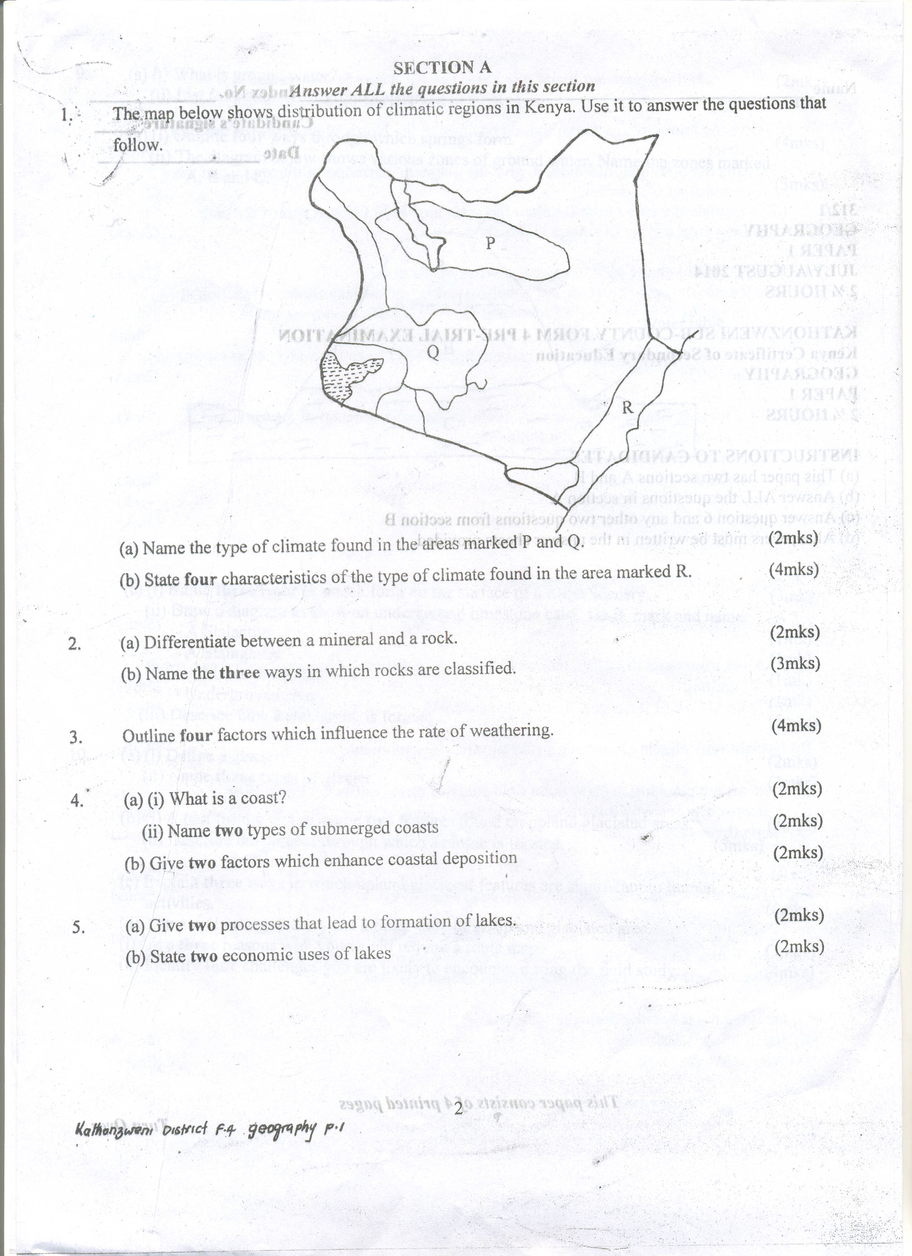
(a) Name the type of climate found in the areas marked P and Q. (2mks)
(b) State four characteristics of the type of climate found in the area marked R. (4mks)

2. (a) Differentiate between a mineral and a rock. (2mks)
(b) Name the three ways in which rocks are classified. (3mks)

3. Outline four factors which influence the rate of weathering. (4mks)

4. (a) (i) What is a coast? (2mks)
(ii) Name two types of submerged coasts. (2mks)
(b) Give two factors which enhance coastal deposition. (2mks)

5. (a) Give two processes that lead to formation of lakes. (2mks)
(b) State two economic uses of lakes. (2mks)

SECTION B
Answer question 6 and any other two questions in this section
6. Study the map of Tambach (1:50,000)(sheet no. 90/3) provided and answer the questions
a) (i) Give the map title. (1 marks)
(ii) Identify two types of scale shown on the map. (2 marks)
(iv) Identify two man made features found in Grid Square 0555 (2 marks)
(v) Measure the length of dry weather road near Kaptagat Forest. Give your answer in kilometers. (2 marks)
(b) (i) Draw a rectangle measuring 8cmby 6cm to represent the area bound by Eastings 88 and 96 and Northings 66 and 72. (1mark)
On the rectangle, mark and name the following; (3marks)
- River Kerio
- Seasonal swamp
- Air photo principal 78
( ii) Calculate the new scale of the rectangle (2mks)
(c) Citing evidence, explain two factors that favor saw milling in the area covered by the map. (4marks)
(d) Describe the drainage of the area covered by the map. (4marks)
(e) Citing evidence, identify four economic functions of Tambach town. (4marks)

7. (a) (i) Apart from the Rift valley, name two other relief features that were formed as a result of faulting. (2mks)
(ii) With the aid of well labeled diagrams, describe how a Rift valley is formed by tensional forces. (8mks)
(b) Explain four effects of faulting on the physical environment. (8mks)
(c) Students are planning to carry out a field study of an area affected by faulting.
(i) State four reasons why it is important for the students to have a pre-visit of the area. (4mks)
(ii) Name three types of faults they are likely to study. (3mks)

8. (a) (i) What is hydrological cycle? (2mks)
(ii) Draw a well – labeled diagram of the hydrological cycle. (5mks)
(b) (i) What is the difference between a river tributary and a distributary? (2mks)
(ii) State four factors which influence the ability of a river to deposit materials. (4mks)
(iii) Describe three ways by which a river transport its load. (6mks)
(c) Describe the following drainage systems:
(i) Superimposed drainage. (4mks)
(ii) Antecedent drainage. (2mks)

9. (a) (i) What is ground water? (2mks)
(ii) List four sources of ground water. (4mks)
(b) (i) Outline four ways through which springs form. (4mks)
(ii) The diagram below shows various zones of ground water. Name the zones marked A,
B and C. (3mks)
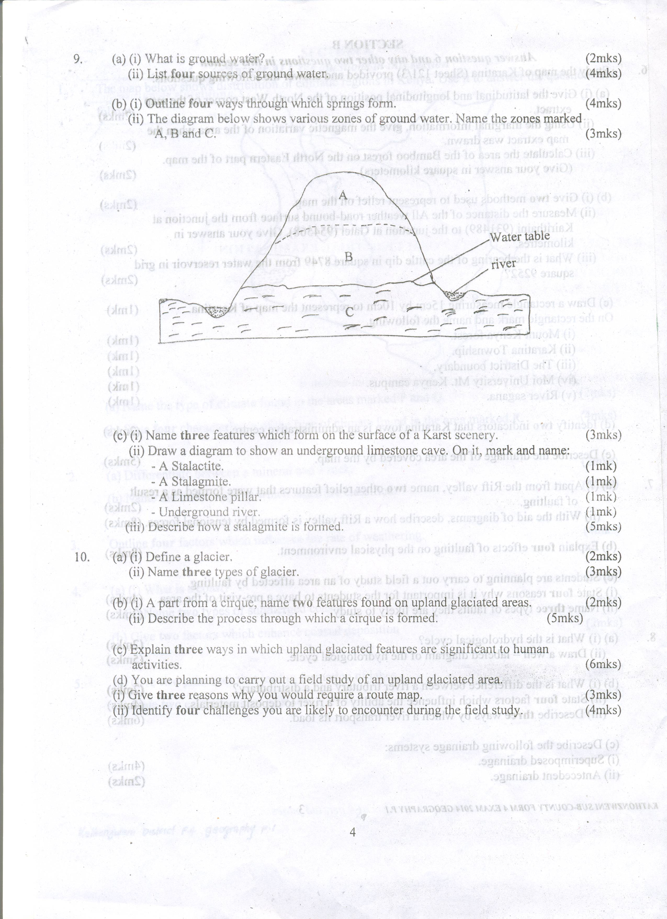
(c) (i) Name three features which form on the surface of a Karst scenery. (3mks)
(ii) Draw a diagram to show an underground limestone cave. On it, mark and name:
- A Stalactite. (1mk)
- A Stalagmite. (1mk)
- A Limestone pillar. (1mk)
- Underground river. (1mk)
(iii) Describe how a stalagmite is formed. (5mks)

10. (a) (i) Define a glacier. (2mks)
(ii) Name three types of glacier. (3mks)
(b) (i) A part from a cirque, name two features found on upland glaciated areas. (2mks)
(ii) Describe the process through which a cirque is formed. (5mks)
(c) Explain three ways in which upland glaciated features are significant to human activities. (6mks)
(d) You are planning to carry out a field study of an upland glaciated area.
(i) Give three reasons why you would require a route map. (3mks)
(ii) Identify four challenges you are likely to encounter during the field study. (4mks)

